**Liquidity Page Re-design Intructions**

Globant will design and build the liquidity page:

* 1. We will provide that person with 3 HTML files showing what the liquidity page contains. There are three files because the current liquidity page contains 2 drill-down feature (see details below).
  2. We will have a screensharing presentation to show the Globant team how the current liquidity page is used so they can have an idea of how a properly redesigned page should be used

**Here is the list of tools/libraries currently used in the IMS and that will need to be used by the Globant team:**

1. Python 2.7.10
2. HTML
3. CSS
4. Javascript
5. Jinja2
6. HandsonTable
7. Min.chart.js
8. D3.min.js
9. Socket.io 1.3.5
10. Jquery-1.10.2
11. JqueryUI 1.10.4
12. Spin.js.org 2.1.3
13. Bootstrap 3.2.0
14. Bootstrap-Table 1.10.1

**Contents of the Liquidity Page:**

The data displayed in the page can be split into two groups: Our suppliers’ quality of service (the two tables at the top of the page) and the quality of the product they provide (the two tables and the plot at the bottom of the page).

1. **Average grade for our suppliers’ quality of service**: this data is contained in the two tables at the top of the page (see screenshot below from *liquidity.html*). The table on the left is for our New York suppliers, and the one on the right for our London suppliers. For each supplier, we see the number of currency pair they offer, the number of components they are graded on, the tier their average grade puts them in and finally, their “liquidity quotient”, which is the supplier’s average grade. The column “From Date” shows from which date the data selected to grade supplier was taken.

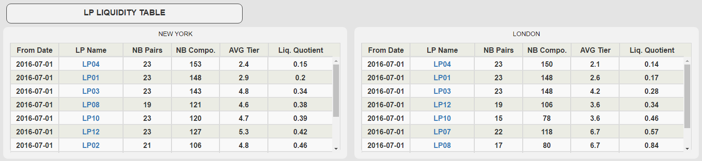

***Screenshot 1: liquidity.html top section***

The links we can see in the column LPName lead to the page “Liquity_LP_Specific”, which gives us details on the liquidity quotient of a specific LP. The page “Liquidity_LP04_Specific.html” was provided as an example (see screenshot below). We get to this page by clicking on “LP04” in the London table in the screenshot above. This page contains the grades and tier given to the supplier on each currency pair it provides (each pair is graded on up to four components – the rank type column).

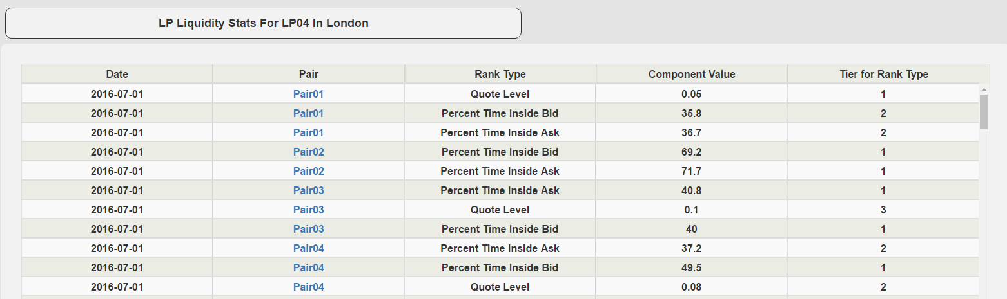

Finally, the links in the “Pair” column in the screenshot above lead to a further drill-down showing only the grades for the pair selected (see the page “Liquidity_LP04_Pair01_Specific.html”.

1. **The quality of the product provided by our suppliers:** this is the bottom section of the page. This section of the page is controlled by the three dropdown lists in the top right corner (Pair, location and level). When the value selected in those lists is changed, the page reloads to display the data corresponding to the selection. The table on the left shows the quality of the product for each supplier over 45 minutes intervals during the day. When you click on the table, it switches to a plot showing the same numbers for the top five suppliers over the period of time selected.

The table on the right shows the evolution of the quality of the product for each supplier between the past two time ranges (it can be the evolution between two days ago and yesterday, last week vs this week or last month vs this month). This allows us to see improvements in the suppliers’ products. The values in this table are also the ones used for the plot at the bottom of the page.

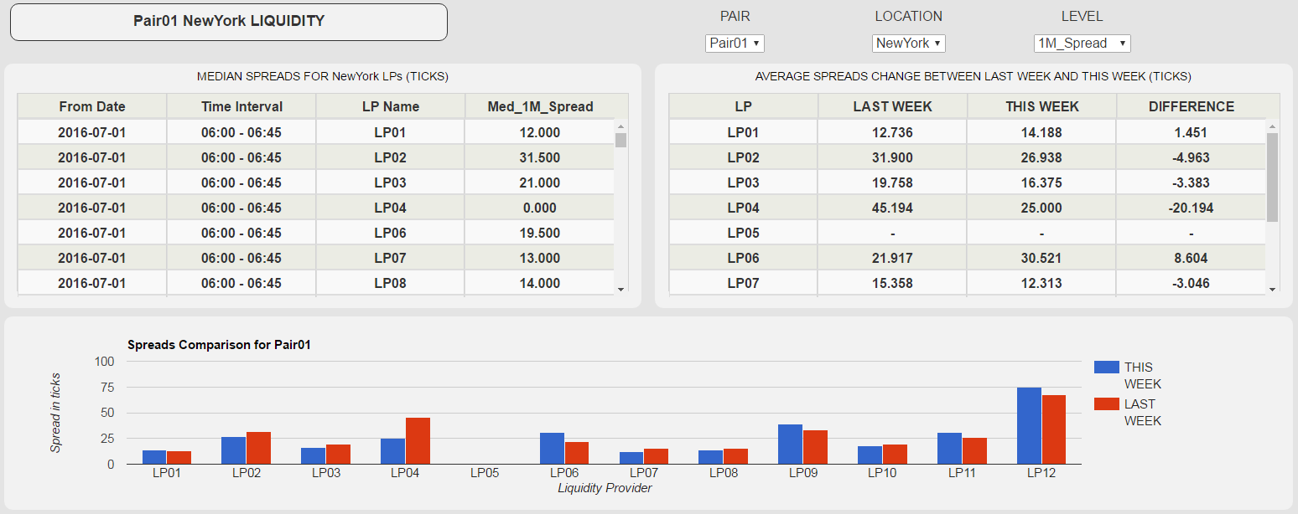

**Suggestions for the re-design:**

1. For the top-section, the quality of the service provided, we would like to no longer have to go into a sub-page to get the drill-down information. Instead, it would be better for all the information to be displayed in this page.
2. For the left-side table in the bottom section, we would like to get rid of the plot/table switch feature. Instead, it would be better to either get rid of the plot completely or find some way to incorporate it into the table, the way we have in the newer version of the IMS (see the page ‘index.html’).